**Student Questions**

Learn about the internals of a standard PC case by examining physical samples and selecting and labeling images found on-line. Gain deeper knowledge by researching and reporting on specific components.

PC Tower Case

1. Find one (or more) images that clearly show the internals of a PC Tower Case.   
   (i.e. Google images using keywords “PC Case Internals”)  
   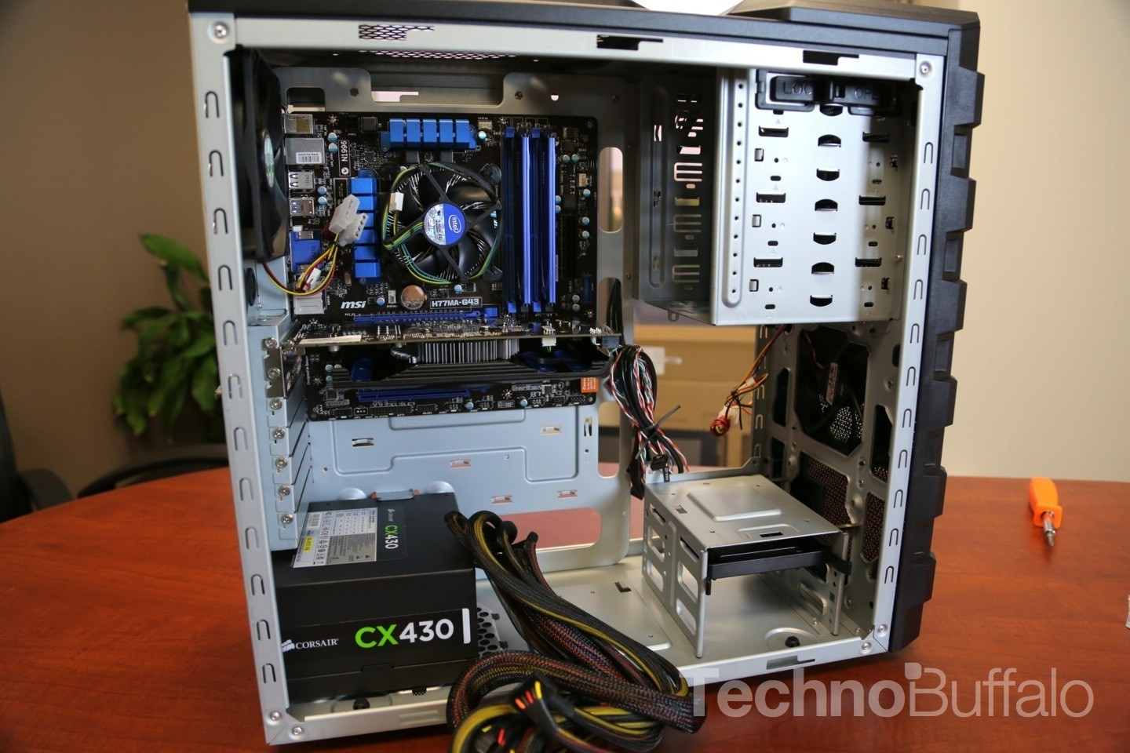
2. Clearly label the following components (using arrows) on your image of the PC case internals:
   1. Motherboard
   2. Power Supply
   3. Solid State Drive
   4. Optical Disk Drive (e.g.DVD)

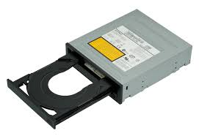

* 1. Cooling Fan
  2. USB Expansion Ports
  3. Monitor Port
  4. Audio Ports
  5. Ethernet Port

1. Research more in-depth about “Hard Disk Drives”. Make notes on the following:
   1. What different versions are currently available (speed and capacity)

The largest capacity currently available hard disk drive is called the Exos x16 HDD and has 15 terabytes of space. The average HDD sold today has around 500 gigabytes of space. HDDs have to manually spin in order to work. There are the more powerful SDDs now that do not need to do this and are faster but the average HDD has a read speed of 128 MB and a write speed of 120 MB.

* 1. How the capacity of the component has changed since the 1980’s?

In the 1980’s the average HDD had a capacity of about 1 gigabyte, the highest end HDD today has 15,000 times that which shows how far we’ve come

PC Motherboard

1. Find one (or more) images that clearly show the layout of a PC Motherboard.   
   (i.e. Google images using keywords “PC Motherboard”)

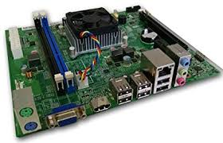

1. Clearly label the following components (using arrows) on your image of the PC motherboard:
   1. CPU (and fan)
   2. RAM Memory
   3. Disk Drive Interface (IDE or SATA)
   4. GPU Graphics Processor (either on-board or Graphics Card)
   5. Sound Processor (either on-board or Sound Card)
   6. Wi-Fi / Ethernet Network Interface (either on-board or Graphics Card)

1. Research more in-depth about “CPU Processor Chip”. Make notes on the following:
2. What different versions are currently available (speed and capacity)

The two largest companies that produce CPUs are intel and AMD intel has the i9 with 8 cores 16 theads and 3.6 GHz and the Ryzen Threadripper 2990WX which has 32 cores, 64 threads and 4.2 GHz for about 4x the price

1. How the speed of the component has changed since the 1980’s

The average CPU in the 1980s had about 8 MHz which made it very slow compared to those of today.

Peripheral Devices

1. Find one (or more) images that clearly show the layout of the back of a typical PC tower case.   
   (i.e. Google images using keywords “Back Of PC Tower”)  
     
   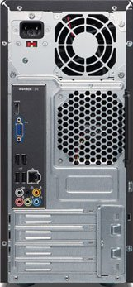
2. Clearly label the following components (using arrows) on your image of the back of a typical PC tower case:
   1. Power cord and power switch
   2. Monitor Interface (VGA or DVI or HDMI)
   3. Mouse Interface (USB or PS/2)
   4. Keyboard Interface (USB or PS/2)
   5. USB Ports
   6. Audio Inputs / Outputs
   7. Ethernet Interface

1. Research more in-depth about “External Portable Storage”. Make notes on the following:
2. Floppy Disks
   * + Read by an FDD
     + Used by all from 1970’s to early 2000’s
     + Some software still uses floppy disks as save images (look at the top left)
     + Now a relic of the past and mostly unused
3. CD-ROM / DVD / Recordable CD/DVD
   * + Read and written by disk drive
     + Standard storage around 10 GB
     + Used lasers to read and write
     + Computers manufactured with disk drives less today
4. USB Memory Drives
   * + More durable than disks
     + More storage on average drive
     + Much more storage on larger drives
     + Easily written and rewritten
5. Compact Flash Memory
   * + Very small and portable
     + Used mostly in cameras and other portable devices
     + Holds little memory compared to other systems
6. Cloud Based Storage
   * + Data not physically held by user
     + Uploaded then kept in servers in places near user
     + People or companies buy storage from owners of server farms
     + Old technology that is starting to be picked up more today

**Presentation Outline**

Explore the development and features of a specific PC hardware component through deeper research and investigation. Work in partners to create a short presentation. Deliver the presentation to the class.

Each group will research a unique PC hardware component. Your specific topic will be assigned from the list provided below.

**Presentation Structure**

1. Explain what the PC component does and how it fits together with other components to make up a fully functioning PC.
2. Explain how the PC component works. Provide a diagram (image) showing the main parts of the component.
3. Research the current state of the art of the component in terms speed, capacity (size), and other related factors.
4. Research on-line suppliers that sell the PC Component. List the specifications for the available products and the cost (price).
5. Research how the PC component has changed and evolved since the early days of PCs in the 1980’s. Cover each of the following topics separately:
   1. Component Speed
   2. Component Size / Capacity
   3. Two other specifications specific to the PC component (ask Mr. Nestor)

**PC Component Topics**

|  |  |  |
| --- | --- | --- |
| **Topic** | **Partner 1** | **Partner 2** |
| CPU Microprocessor Chip |  |  |
| Motherboard Layout |  |  |
| Computer Graphics |  |  |
| Sound & Audio |  |  |
| Hard Disk Drives |  |  |
| Removable Disk Storage |  |  |
| Ethernet / Fiber Connectivity |  |  |
| Wifi / Bluetooth Connectivity |  |  |
| Mouse / Pointing Devices |  |  |
| Monitor & Display Technology |  |  |
| Printers & Output Technology |  |  |